***Exercise:***

**Question # 01:**Write an algorithm which takes 10 input numbers and display the second largest number.

**Question # 02:** Write an algorithm Print Hello World 10 times

**Question # 03:** Write an algorithm to check whether a given number is prime or not.



**Question # 04:** Draw a flowchart to log in to facebook account

**Question # 05**: Perform all preprogramming phase a farmer has some chickens and some goats. Together there are 43 heads and 108 legs. How many chickens does the farmer have? How many goats?

**Question # 06:** Perform all preprogramming phase which takes 8 numbers as input in variables a-h, then computes the following formula and displays the output to screen.



**Question # 07:** Perform all preprogramming phase Raza was not feeling well; he went to the doctor. Doctor check Raza and prescribe him 3 tablets in the morning, 5 tablets in the afternoon and 3 tablets at night. Based on the input find out the total number of tablets Raza takes in a day.

**Question # 08:** Perform all preprogramming phase that asks user to give number of days as input and returns the number of years, weeks, and days. Assume every year has 365 days and every month is of 30 days.

**Question # 09:** Write the algorithm and flowchart Take no. of units consumed from user, then calculate his/her Electricity bill based on following information:

|  |  |  |  |  |  |  |
| --- | --- | --- | --- | --- | --- | --- |
|  | **No. of Units consumed** |  |  | **Cost per unit** |  |  |
|  |  |  |  |  |
|  |  |  |  |  |  |  |
|  | **1 - 100** |  |  | Rs. 05.25 |  |  |
|  |  |  |  |  |  |  |
| **101 - 200** | |  |  | Rs. 07.75 | |  |
|  | |  |  |  | |  |
|  | **201 - 300** |  |  | Rs. 08.92 |  |  |
|  |  |  |  |  |  |  |
| **301 - 400** | |  |  | Rs. 11.55 | |  |
|  | |  |  |  | |  |
|  | **400+** |  |  | Rs. 12.71 |  |  |
|  |  |  |  |  |  |  |

**Question # 10:** Perform all preprogramming phase a company is giving an increment to its employees who have served longer than 3 years. Write a program that will require the employee to input year of service and their salary. Your program then has to calculate the increment in salary based on the table below.

|  |  |  |  |  |  |  |  |
| --- | --- | --- | --- | --- | --- | --- | --- |
|  | **Salary** |  |  |  | **Increment** |  |  |
|  |  |  |  |  |  |  |
|  |  |  |  |  |  |  |  |
|  | **Salary>=40000** |  |  |  | 2% |  |  |
|  |  |  |  |  |  |  |
|  |  |  |  |  |  |  |  |
|  | **40000 PKR < Salary >=20000** | | | 2.5% | |  |  |
|  |  |  |  |  |  |
|  | **PKR** | | |  |  |  |  |
|  |  | | |  |  |  |  |
|  | **20000 PKR < Salary >=15000** |  |  |  | 4.0% |  |  |
|  |  |  |  |  |  |  |
|  | **PKR** |  |  |  |  |  |  |
|  |  |  |  |  |  |  |  |
|  | **15000 PKR < Salary >=10000** | | | 7.0% | |  |  |
|  |  |  |  |  |  |
|  | **PKR** | | |  |  |  |  |
|  |  |  |  |  |  |  |  |

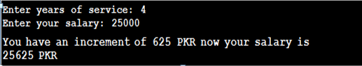

**Question # 11:** Write an algorithm that raise ‘a’ to the power ‘b’ and store in exp. where ‘a’ and ‘b’ are user inputs.



**Question # 12:** Write an algorithm that produce table of a user given number.

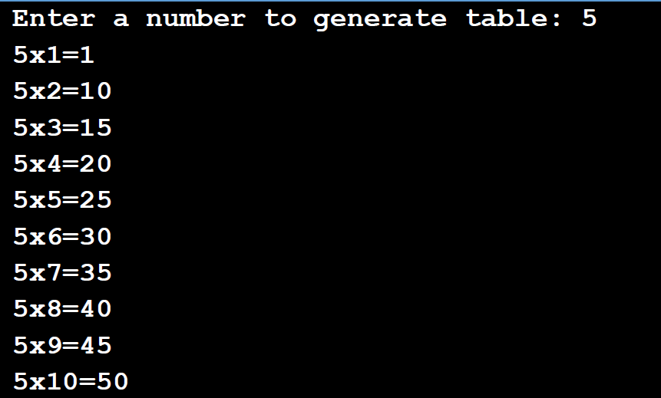

**Question # 13:** Write if statements to do the following:

1. If character variable taxCode is ’T’, increase price by adding the taxRate percentage of price to it.
2. If integer variable opCode has the value 1, read values for X and Y and calculate and print their sum.
3. If integer variable currentNumber is odd, change its value so that it is now 3 times current Number plus 1 otherwise change its value so that it is now half of current Number.
4. Assign true or 1 to the boolean variable leapYear if the integer variable year is a leap year. (Aleapyear is a multiple of 4, and if it is a multiple of 100, it must also be a multiple of 400.)

**Question # 14:** Name the data type for each of the following constants. Explain your answer.

1. 5.38
2. “87654”
3. True
4. “A”
5. “707-434-5555”
6. “New York”
7. -389
8. 2.45E6
9. 48976.0
10. False

**Question # 15:** Find the result of the following operations:

1. 5 + 4
2. 10/2
3. True OR False
4. 20 MOD 3
5. 5< 8
6. 25 MOD 70
7. “A” > “H”
8. NOT True
9. 25/70
10. False AND True
11. 20 * 0.5
12. 35 <= 35
13. 35/7
14. False OR False
15. True AND True
16. 50 MOD 5
17. -35 < 67
18. 4.0 ^ 3
19. 60\9
20. 35 < 35
21. True AND False

**Question # 16:** Evaluate the following equations, given the values A = 12, B = 3, C = 6, D = 2:

1. F=A + B/C – D ^ 2
2. F=(A + B)/C – D ^2
3. F = A + B/(C – D ^2)
4. F=(A + B) MOD C
5. F=(A + B)/ D ^2

**Question # 17:** Write the following equations in computer form:

1. X = Y + 3Z – (Z + Y)/ (Z – 3)
2. X = 5Y + (3Z – 1)/4(3Z + 1) – Y
3. X = (X – Y)2

**Question # 18:** Create a table that gives all possible answers for the following logical equations. (Include the structure of the order of processing—see page 33 for example.) Make clear how you set up the table.

1. R = A OR B
2. R = NOT A OR B
3. R = A AND B AND (B OR C)
4. R = NOT (A OR B) AND NOT (B OR C)
5. R = B AND NOT (A OR C) OR NOT (B AND C)

**Question # 19:** Evaluate the following for the values A = 5, B = 2, C = True, D = False. (Include the structure of the order of processing.)

1. R = A + 3 > B - 1 AND C OR D
2. R = NOT C OR D OR A - 3 <= B

**Question # 12:**

What is wrong with these variable names? Can you correct them?

1. **City Name** referencing the name of a city.
2. **Client-name** referencing a client name.
3. **City/State** referencing a city and state.
4. **LN** referencing a last name.
5. **Street address**
6. **Street_Address_for_Joe’s_Hardware_Supply_Incorporated_Client**